What is the CLOUD?

1. think of cloud computing as using computing resources somewhere else, other than what you own or what you have immediately available with you. When you're using both personal and business cloud computing resources, you're using computing resources that somebody else uses that is hosted somewhere far away from you, that you access over an internet connection.
2. Little Technical - when you are accessing cloud resources somewhere else, what you are actually doing is you're accessing computing resources hosted in a remote data center in various places, all around the world.
3. Cloud Terminology

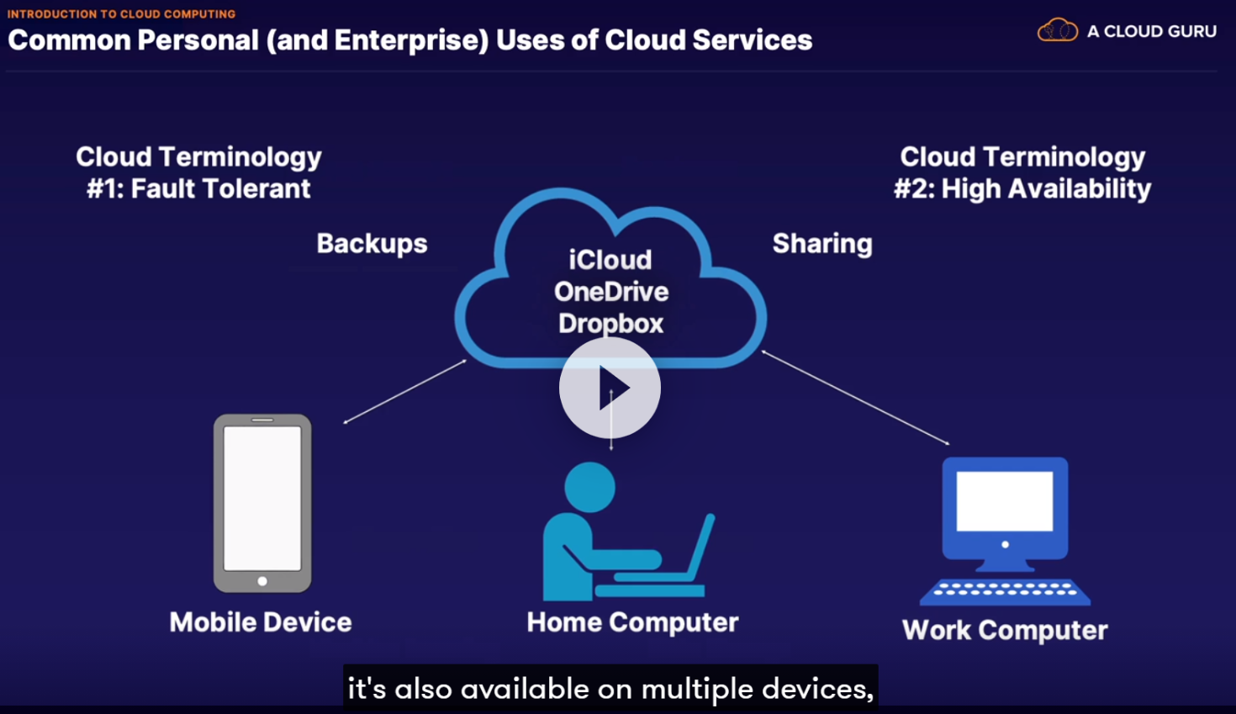

1. example of fault tolerance. In other words, if your device has a fault, it crashes, it goes down, it breaks -- yes, the device is gone and you have to replace it. However, your data is safe because it is safely copied to those remote cloud services,regardless of what happens to your own personal devices.
2. High Availability Example - example, if you're on your mobile device and you access a document or some images or some movie files hosted in Dropbox, you also have access to those very same files from your home computer, work computer, or any other device, which is linked to the same Dropbox account.
3. The data lives in one location -- that is your Dropbox account -- however, it is highly available on any of your other devices that it uses.
4. SCALABILITY - Scalability is a process in which you can automatically increase your computing capacity to meet user needs with no additional input from you.

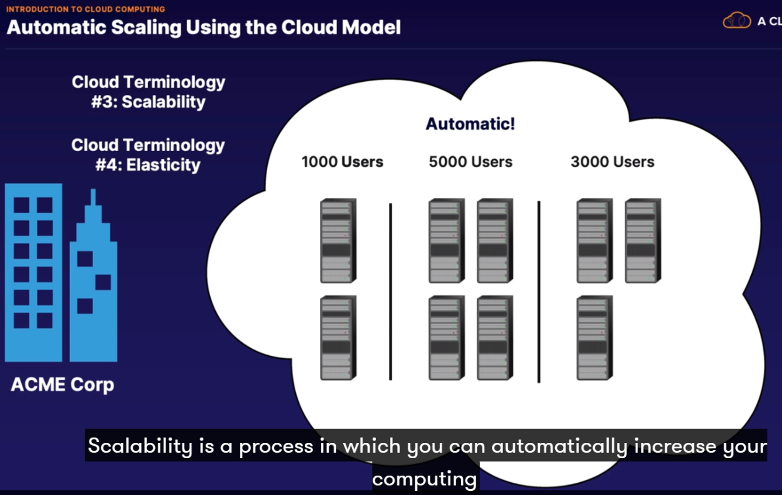

1. elasticity is simply the reverse of scalability, in which you can automatically shrink your computing capacity to meet the use need at that moment.